Null Hypotheses:

- H_{o} – for PS is that the number of LEFT and RIGHT turns are same
- H_{o} – for PA is that the number of LEFT and RIGHT turns are same
- H_{o} – for PR is that the number of LEFT and RIGHT turns are same

Alternative Hypotheses:

- H_{a} – for PS is that the number of LEFT and RIGHT turns are not same
- H_{a} – for PA is that the number of LEFT and RIGHT turns are not same
- H_{a} – for PR is that the number of LEFT and RIGHT turns are not same

Write-up:

- For the PS questions, the sign test result indicates a significant result (N = 24, z = .019, p <.05) that rejects the null hypothesis that for PS the number of LEFT and RIGHT turns are same. This indicates that for PS questions, more liars turn their eyes to right than left significantly.
- For the PA questions, the sign test result indicates a significant result (N = 24, z = .039, p <.05) that rejects the null hypothesis that for PA the number of LEFT and RIGHT turns are same. This indicates that for PA questions, more liars turn their eyes to right than left significantly.
- For the PR questions, the sign test result indicates a non-significant result (N = 24, z = .815, p>.05) that fails to reject the null hypothesis that for PA the number of LEFT and RIGHT turns are same. This indicates that for PR questions, there is no significant difference for the liars to turn their eyes to the left or to the right.

Data file:

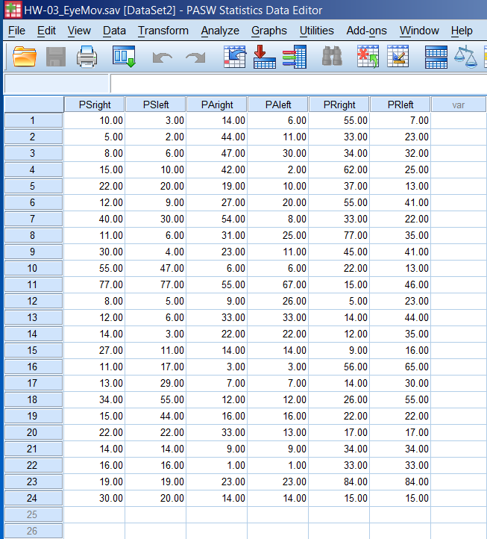

SPSS Output:

NPar Tests

Descriptive Statistics
 | N | Mean | Std. Deviation | Minimum | Maximum
PSright | 24 | 21.6667 | 16.61761 | 5.00 | 77.00
PAright | 24 | 23.2500 | 16.00611 | 1.00 | 55.00
PRright | 24 | 33.7083 | 21.61215 | 5.00 | 84.00
PSleft | 24 | 19.7917 | 18.99423 | 2.00 | 77.00
PAleft | 24 | 16.2083 | 13.94080 | 1.00 | 67.00
PRleft | 24 | 32.1250 | 17.91116 | 7.00 | 84.00

Sign Test
Frequencies
 |  | N
PSleft - PSright | Negative Differences^{a,b,c} | 15
PSleft - PSright | Positive Differences^{d,e,f} | 4
PSleft - PSright | Ties^{g,h,i} | 5
PSleft - PSright | Total | 24
PAleft - PAright | Negative Differences^{a,b,c} | 10
PAleft - PAright | Positive Differences^{d,e,f} | 2
PAleft - PAright | Ties^{g,h,i} | 12
PAleft - PAright | Total | 24
PRleft - PRright | Negative Differences^{a,b,c} | 10
PRleft - PRright | Positive Differences^{d,e,f} | 8
PRleft - PRright | Ties^{g,h,i} | 6
PRleft - PRright | Total | 24
a. PSleft < PSright
b. PAleft < PAright
c. PRleft < PRright
d. PSleft > PSright
e. PAleft > PAright
f. PRleft > PRright
g. PSleft = PSright
h. PAleft = PAright
i. PRleft = PRright

Test Statistics^{b}
 | PSleft - PSright | PAleft - PAright | PRleft - PRright
Exact Sig. (2-tailed) | .019ª | .039ª | .815ª
a. Binomial distribution used.
b. Sign Test

Eye Movement Sign Test Homework -03 (Part-II)

Alternative Data File

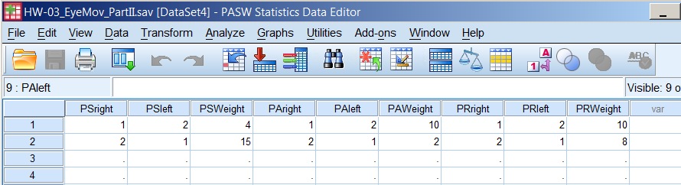

Weight Cases Dialog Window for PSright-PSleft Pair

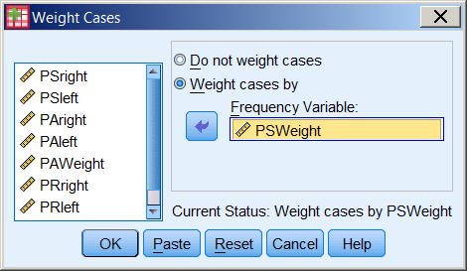

Non-Parametric Sign Test Command Window for Two-Related Samples (PSright-PSleft Pair)

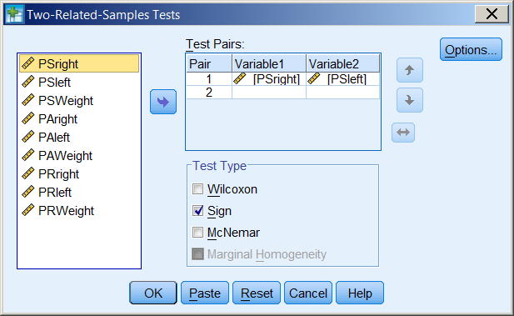

Non-Parametric Sign Test Command Window for Two-Related Samples (PSright-PSleft Pair) Results

NPar Tests

Descriptive Statistics
 | N | Mean | Std. Deviation | Minimum | Maximum
PSright | 19 | 1.79 | .419 | 1 | 2
PSleft | 19 | 1.21 | .419 | 1 | 2

Sign Test
Frequencies
 |  | N
PSleft - PSright | Negative Differencesª | 15
PSleft - PSright | Positive Differences^{b} | 4
PSleft - PSright | Ties^{c} | 0
PSleft - PSright | Total | 19
a. PSleft < PSright
b. PSleft > PSright
c. PSleft = PSright

Test Statistics^{b}
 | PSleft - PSright
Exact Sig. (2-tailed) | .019ª
a. Binomial distribution used.
b. Sign Test

Write-up for PSright-PSleft Pair:

- For the PS questions, the sign test result indicates a significant result (N = 19, z = .019, p <.05) that rejects the null hypothesis that for PS the number of LEFT and RIGHT turns are same. Actually, it indicates that for PS questions, more liars turn their eyes to right than left significantly.
Non-Parametric Sign Test Command Window for Two-Related Samples (PAright-PAleft Pair) Results (After doing Weight Cases for PAright-PAleft Pair)

NPar Tests

Descriptive Statistics
 | N | Mean | Std. Deviation | Minimum | Maximum
PAright | 12 | 1.17 | .389 | 1 | 2
PAleft | 12 | 1.83 | .389 | 1 | 2

Sign Test
Frequencies
 |  | N
PAleft - PAright | Negative Differencesª | 2
PAleft - PAright | Positive Differences^{b} | 10
PAleft - PAright | Ties^{c} | 0
PAleft - PAright | Total | 12
a. PAleft < PAright
b. PAleft > PAright
c. PAleft = PAright

Test Statistics^{b}
 | PAleft - PAright
Exact Sig. (2-tailed) | .039ª
a. Binomial distribution used.
b. Sign Test

Write-up for PAright-PAleft Pair:

For the PA questions, the sign test result indicates a significant result (N = 12, z = .039, p <.05) that rejects the null hypothesis that for PA the number of LEFT and RIGHT turns are same. Actually, it indicates that for PA questions, more liars turn their eyes to right than left significantly.

Non-Parametric Sign Test Command Window for Two-Related Samples (PRright-PRleft Pair) Results (After doing Weight Cases for PRright-PRleft Pair)

NPar Tests

Descriptive Statistics
 | N | Mean | Std. Deviation | Minimum | Maximum
PRright | 18 | 1.44 | .511 | 1 | 2
PRleft | 18 | 1.56 | .511 | 1 | 2

Sign Test

Frequencies
 |  |  |  | N
PRleft - PRright | Negative Differencesª |  |  | 8
PRleft - PRright | Positive Differences^{b} |  |  | 10
PRleft - PRright | Ties^{c} |  |  | 0
PRleft - PRright | Total |  |  | 18
a. PRleft < PRright
b. PRleft > PRright
c. PRleft = PRright
Test Statistics^{b}
 |  | PRleft - PRright
Exact Sig. (2-tailed) |  | .815ª
a. Binomial distribution used.
b. Sign Test

Write-up for PRright-PRleft Pair:

For the PR questions, the sign test result indicates a non-significant result (N = 18, z = .815, p>.05) that fails to reject the null hypothesis that for PA the number of LEFT and RIGHT turns are same. This indicates that for PR questions, there is no significant difference for the liars to turn their eyes to the left or to the right.

